***Customer:***

* Can reach to customer service team and open any case from any channel (like web, phone etc).
* Note: Customer can submit their problem by using the given site url (without having Salesforce credential). [**https://gmailcomshellrecharge-dev-ed.my.site.com/recharge**](https://gmailcomshellrecharge-dev-ed.my.site.com/recharge)

**Screen-1: Customer can fill the below form to submit their case and origin will be considered as Web.**

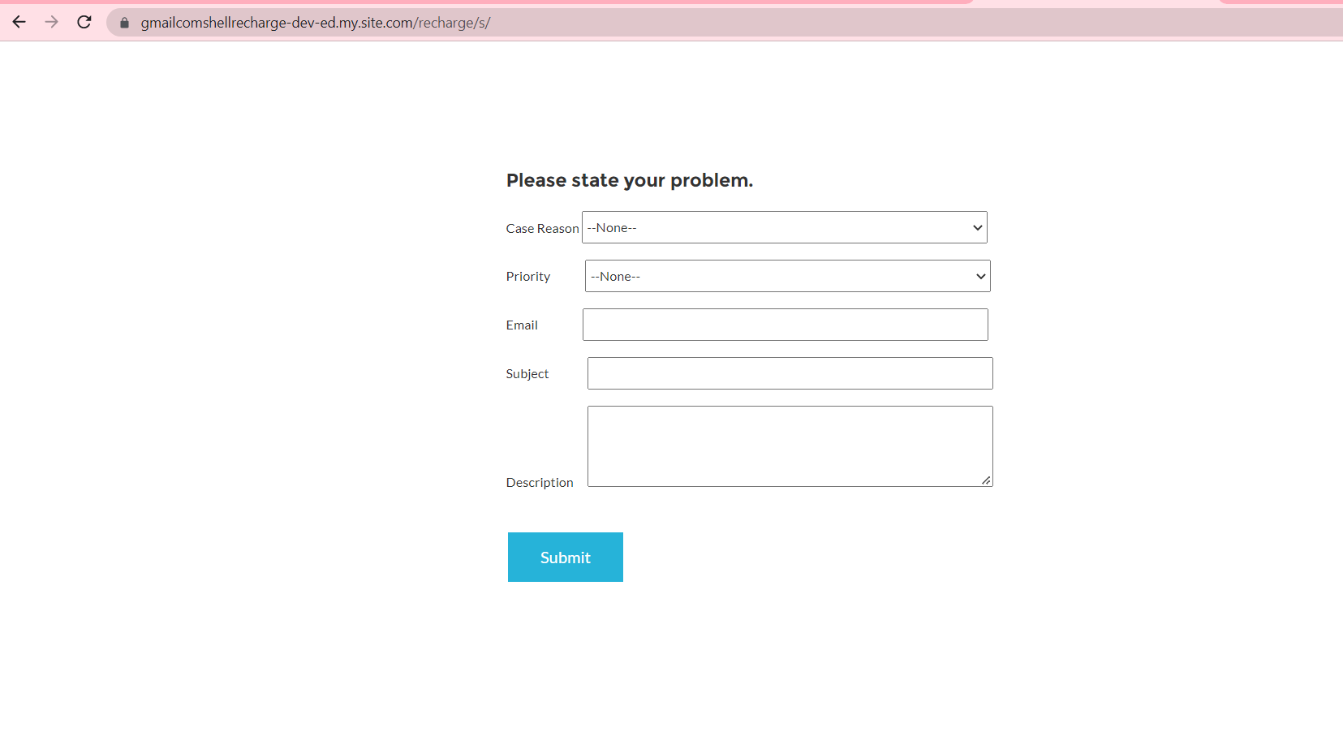

* Will get a notification email on successfully submission of Web form.

**Screen-2: Please refer below screen for notification email.**

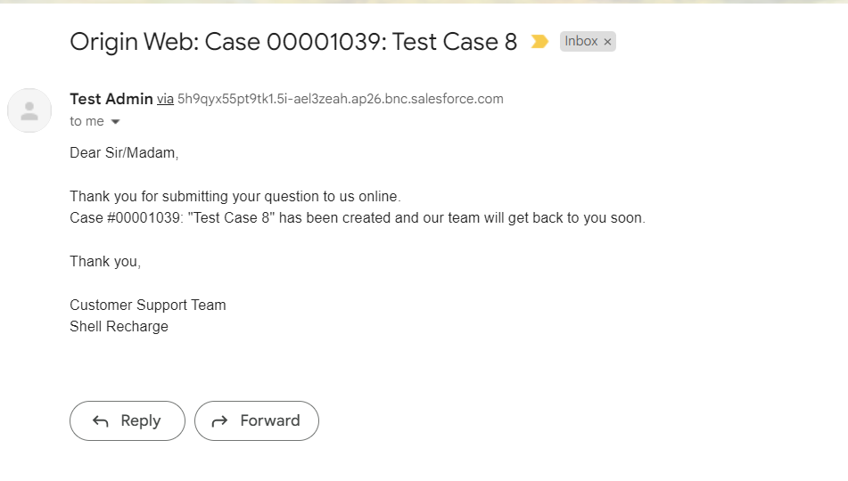

***Customer Support Agent:***

* Can use the standard **Service** **Console** app and opens any case

**Screen-3: Please refer for default app for Customer Support Agent.**

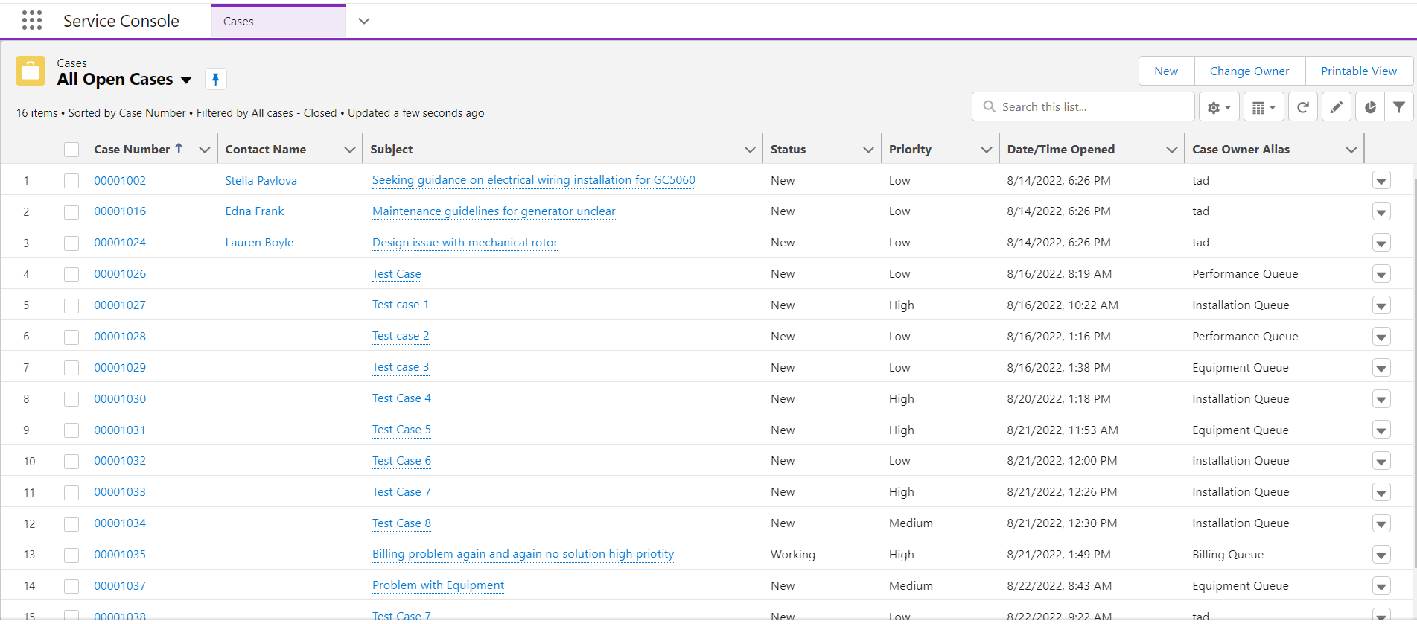

* If the case origin is Web, then case should be assigned to specific support agent team depending on the types of case (like- installation, billing, performance etc.).
* The team member of the specific will get an email notification once the case gets assigned to them.

***Screen-4: Please refer the below screen for notification email which will be assigned to the specific team.***

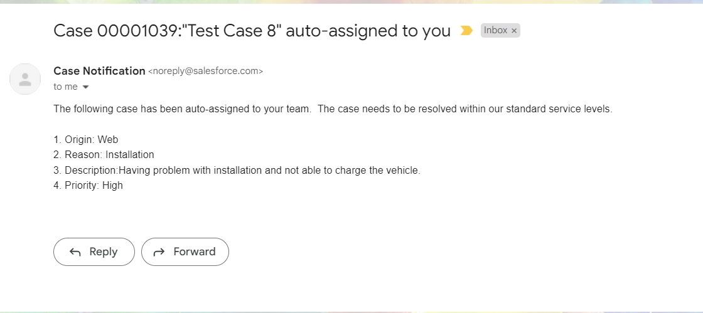

* Can also create new Case manually from Salesforce and the case owner will be the agent.
* We have one dummy user for Customer Support agent.
* User Name: [enrique.m@gmail.com.shellrecharge](mailto:enrique.m@gmail.com.shellrecharge)
* Profile: Custom: Support Profile

***Customer Support Manager:***

* Can use **Shell** app (from app launcher) to view Case table which holds all the cases. The Case table is present under **Home** tab.

***Screen-5:* Please refer the below screen for Shell console app and Case Table under Home tab**

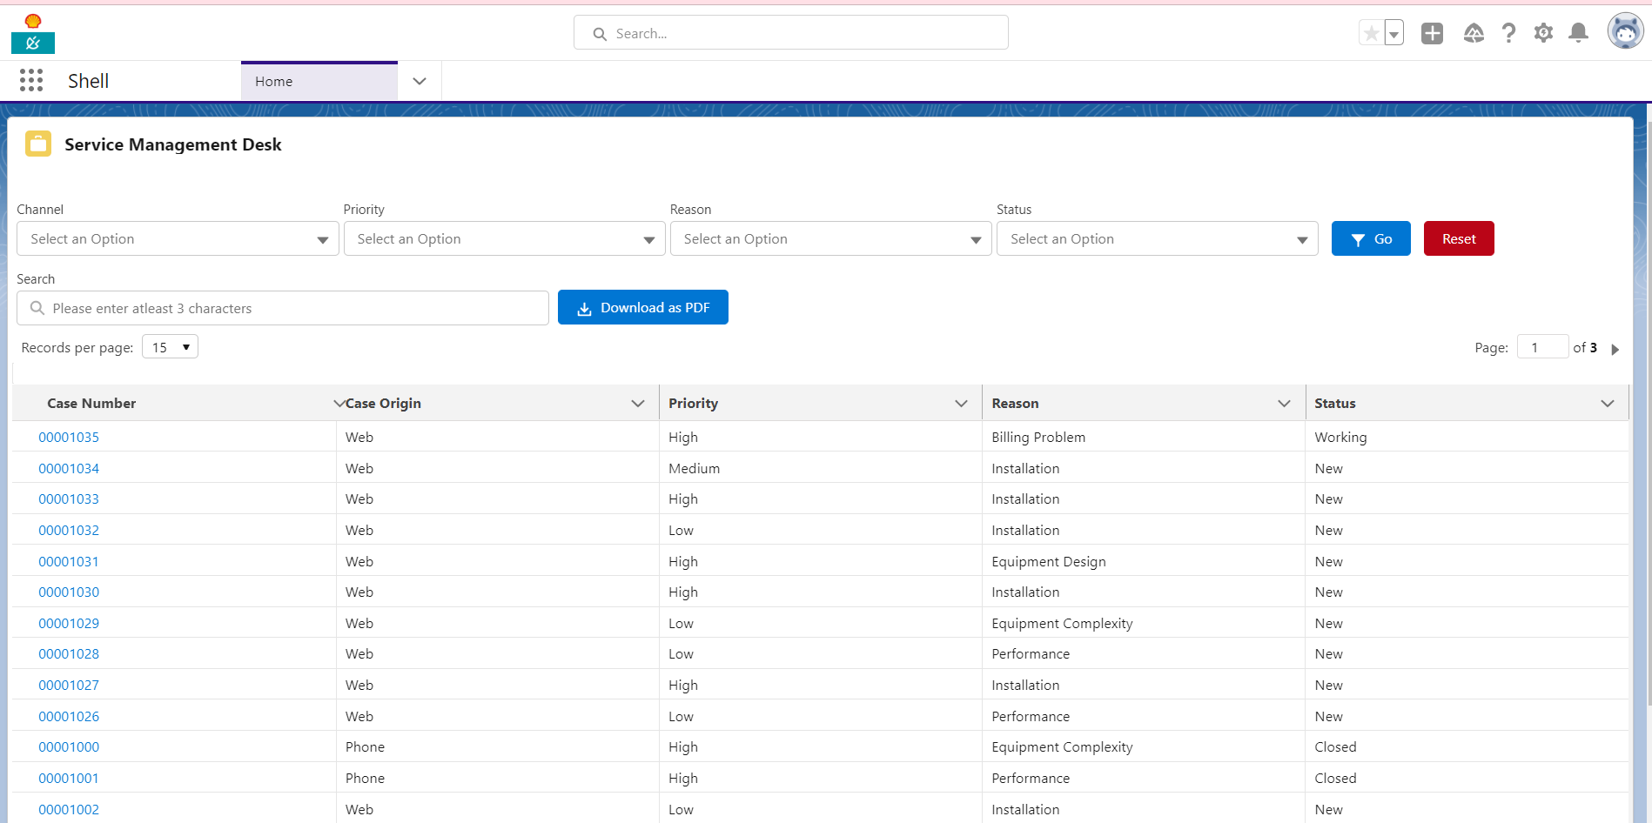

* Can navigate to any specific case details page by clicking the Case Number from the table.

**Screen-6: Please refer the below screen for navigation link (Case Number in the table).**

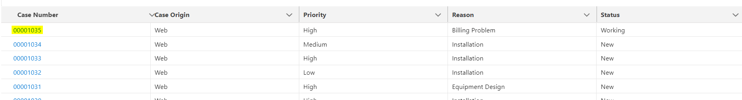

***Screen-7:*** Please refer the below screen for record details page after clicking the specific Case Number from the table.

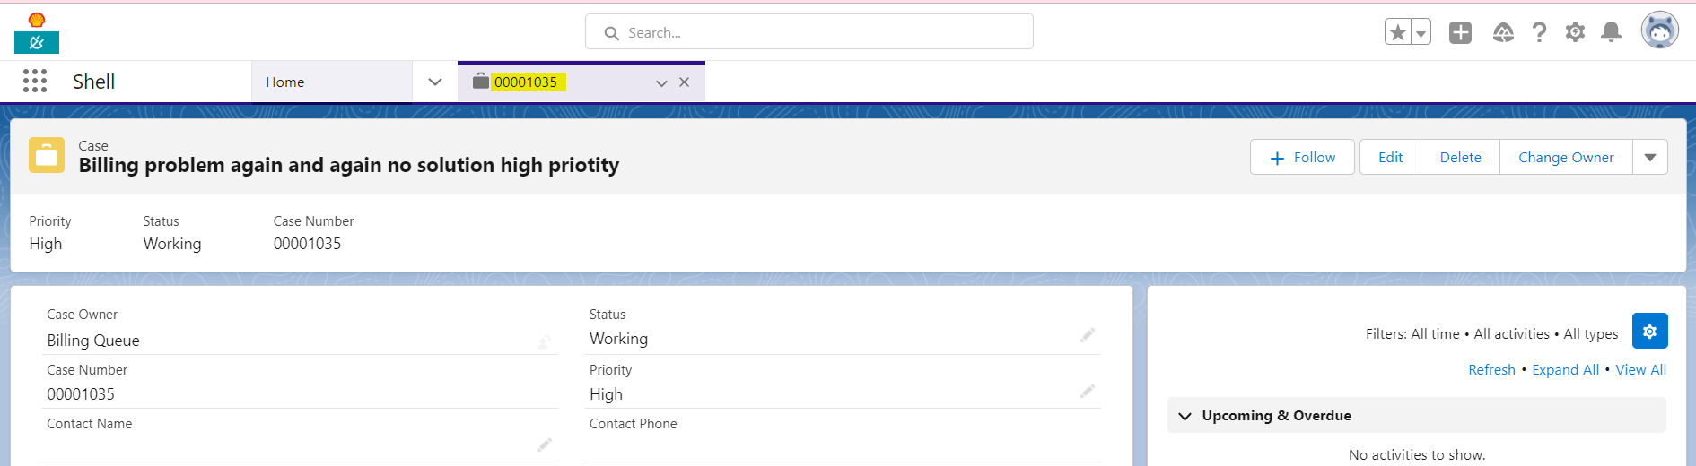

* Can use the filter option to get the filtered data in the Case table.

***Screen-8: Please refer below screen for viewing filtered table.***

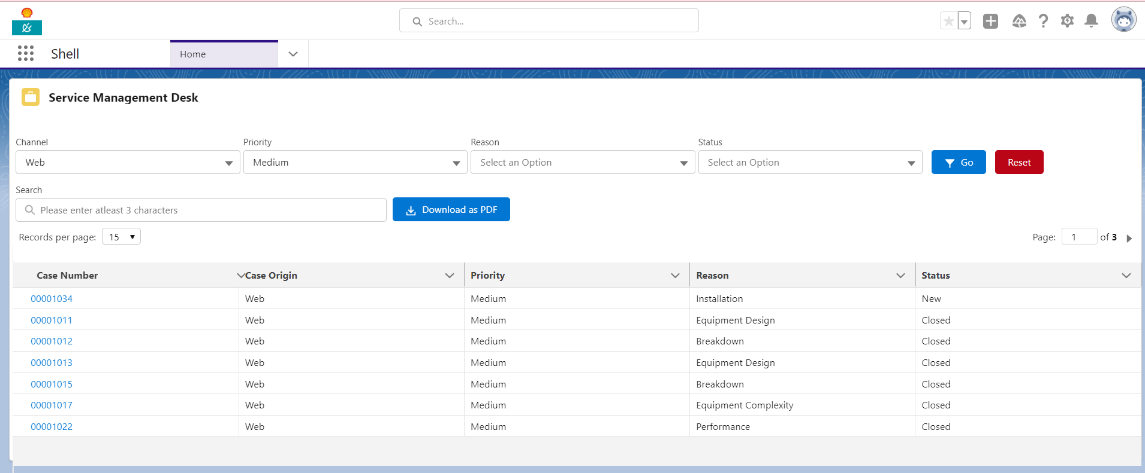

* Can use search option to get specific Case item from the table.

***Screen-9: Please refer for viewing the table data with search key.***

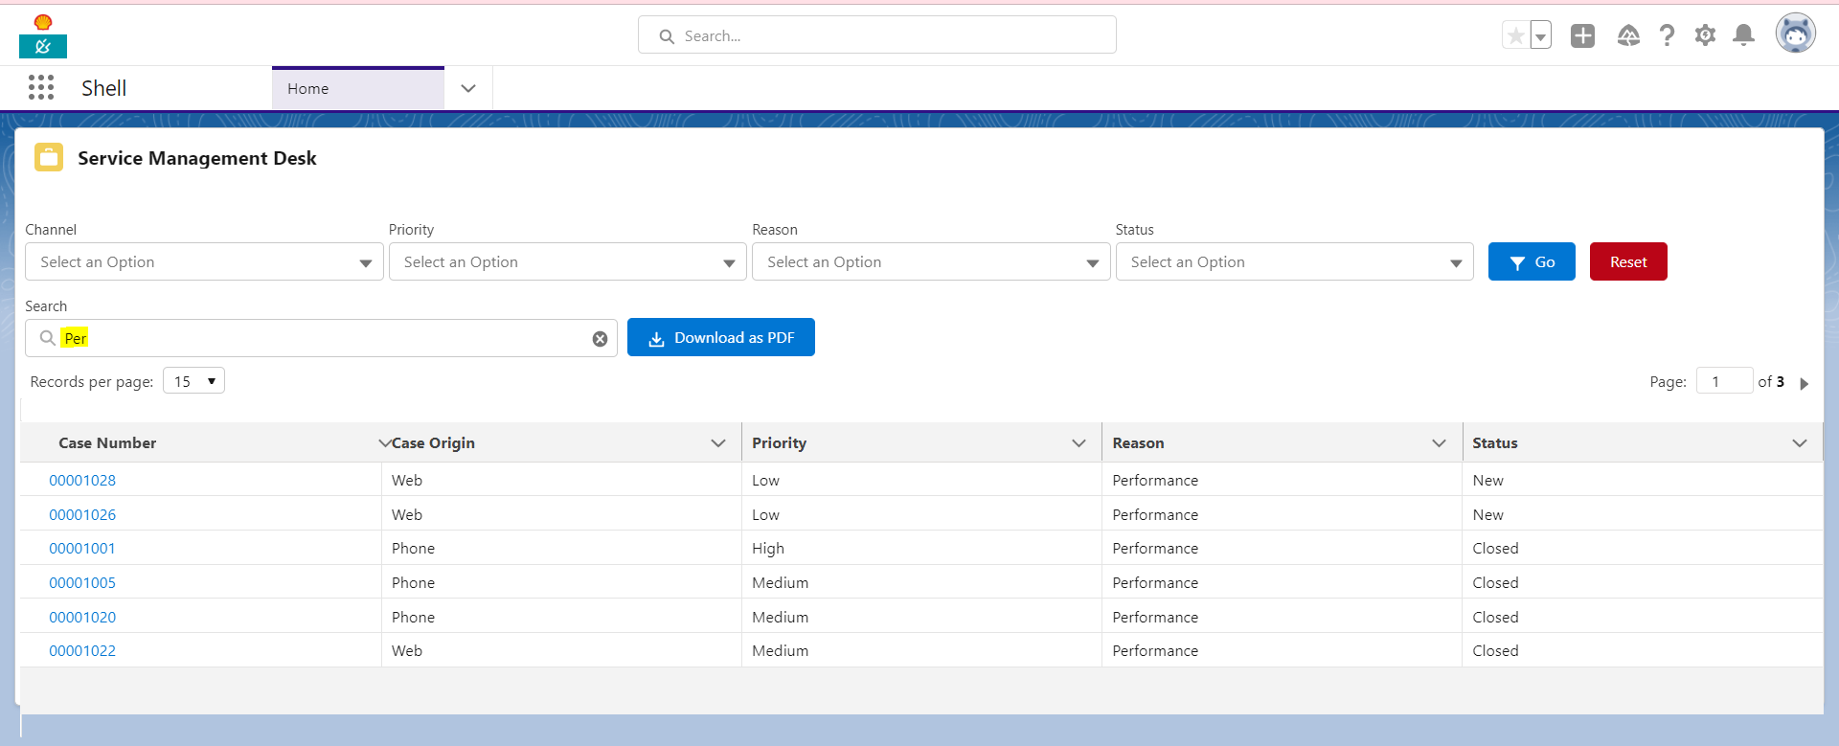

* Can download the table data as PDF format by clicking the ‘Download PDF’ button.
* Can use the pagination option to have to better user experience.
* We have one dummy user for Customer Support manager.
* User Name: test.admin@gmail.com.shellrecharge
* Profile: System Administrator